  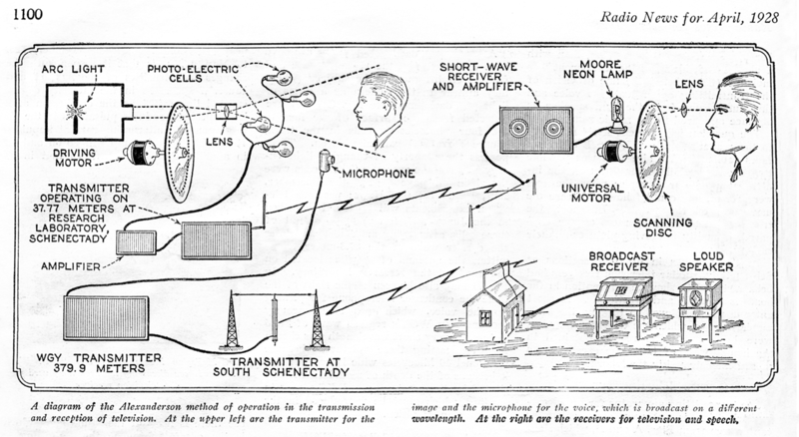  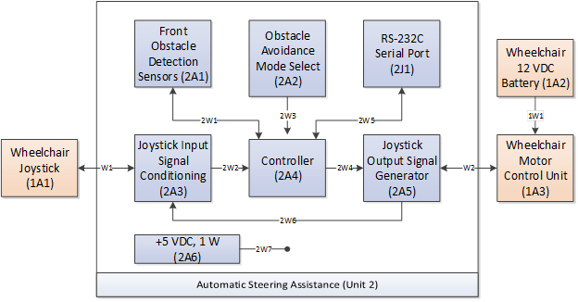 | University of Missouri – Columbia  Department of Electrical Engineering & Computer Science
Report Title
ECE Capstone Project – Proposed Implementation
February 14, 2020
— Engineering Team —
John Doe, Electrical Engineering
First2 Last2, <Degree Program(s) Spelled Out>
First3 Last3, <Degree Program(s) Spelled Out>
John Smith, Electrical Engineering
— Project Advisors —
Dr. <FirstName> <LastName>, PhD [, <Title(s)>]
Department of Electrical Engineering & Computer Science, University of Missouri
[<Salutation>] <FirstName> <LastName>[, <Title(s)>]
[<Department>, ]<Employer>
— Course Instructor —
Mr. Jim Fischer

Table of Contents
NOTE 1Proposed Implementation 6
Ideation 6
Brainstorming 6
Proposed Implementation 6
Theory of Operation 6
Product Concept Diagrams 7
Functional Block Diagrams 8
Unit 1 – <unit1_name> (formatting style: Heading 4) 9
1A1 – <assembly_1a1_name> (Heading 4) 9
1A2 – <assembly_1a2_name> (Heading 4) 9
1A2A1 – <subassembly_1a2a1_name> (Heading 4) 9
Software Architecture 10
Work Assignments 10
NOTE 2References 13

List of Illustrations

List of Tables

Table of Equations

Proposed Implementation
This report describes the possible implementations we considered for this project, and we identify and describe our selected/proposed implementation for this project. Each group member’s work assignments and responsibilities for the proposed Capstone project are summarized at the end of this chapter.

Ideation
In this section we describe the implementations, features, etc. the group considered during brainstorming sessions where the group members ideated possible solutions / implementations of the project. The level of detail provided herein is limited to concept diagrams, functional block diagrams, and software architecture diagrams. Implementation details are not provided herein.

Brainstorming
By <Author’s Name>
outdoor/gazebo/pergola lighting, battery powered, solar charging, 4 hr battery life, AC->DC converter, dimming, mosquito repellent tone, audio visualizations, app control for the audio and power control. Solar panels permanent installation/portable not decided

Proposed Implementation
This section of the report describes the proposed implementation for the Capstone project that we intend to design and reduce to practice during the ECE 4980 semester.

Theory of Operation
The proposed project’s theory of operation is described herein via system diagram figures, functional block diagram figures, software architecture figures, and discussions thereof.

Product Concept Diagrams
By <Author’s Name>
Your text here …
Provide herein one o r more product concept diagrams with written prose that describes the theory of operation of the product’s processes for the proposed implementation. An example product concept diagram figure is provided in Figure 1. A product concept diagram should pictorially describes these physical elements: INPUTS, PROCESSES, and OUTPUTS. Information that enters or acts upon the physical system is an INPUT signal. A physical PROCESS accepts this incoming INPUT signal and produces one or more OUTPUTS (the system’s response to the INPUT signal). The idea is to help the reader understand the main wooden physical elements that comprise the physical product and how those elements interrelate.
Figure 1. Example of a product concept diagram figure. C. G. B. Rowe, Early Television System Diagram, April, 1928. Available from: Wikimedia Commons, https://commons.wikimedia.org/wiki/File:Early_Television_System_Diagram.png.
For additional examples of product concept diagrams, see these pages on Pinterest.com:
- Garden hose handle
- https://www.pinterest.com/pin/837599230666289528
- https://www.pinterest.com/pin/519532506987464957/

Functional Block Diagrams
By <Author’s Name>
Provide herein one or more functional block diagram figures with written prose that describes the theory of operation at a functional level for the proposed implementation. Recall that a functional block diagram pictorially describes the functional structure of the proposed system via these visual elements: SYSTEM, SET, UNIT GROUP, UNIT, ASSEMBLY, SUBASSEMBLY, BASIC PART. As a general rule, do not describe BASIC PARTs in this section. The idea is to help the reader understand the main functional elements that comprise the project, and how those elements interrelate. An example of a system diagram figure is provided in Figure 2.
Figure 2. Example of a functional block diagram figure.
The best way to organize your discussion in this section is a “top down” hierarchical structure—i.e., first describe the system overall; next describe the SETs that make up the system (if any); next describe the unit GROUPs units (if any); next describe the UNITs, and finally, describe the ASSEMBLIES and SUBASSEMBLIES. As a general rule, do not describe BASIC PARTS in this section. For example:

Unit 1 – <unit1_name> (formatting style: Heading 4)
- Opening commentary that briefly summarizes the unit’s purpose and operation.
- Functional block diagram showing the unit’s composition (assemblies, subassemblies) with discussion of the system’s theory of operation.

1A1 – <assembly_1a1_name> (Heading 4)
- Briefly describe using written prose, and possibly generic figures, the function of assembly 1A1 and its theory of operation. DO NOT describe herein assembly 1A1’s implementation details; implementation information is provided in the Individual Contributions reports.

1A2 – <assembly_1a2_name> (Heading 4)
- Briefly describe using written prose, and possibly generic figures, the function of assembly 1A2 and its theory of operation. DO NOT describe herein assembly 1A2’s implementation details; implementation information is provided in the Individual Contributions reports.

1A2A1 – <subassembly_1a2a1_name> (Heading 4)
- Briefly describe using written prose, and possibly generic figures, the function of subassembly 1A2A1 and its theory of operation. DO NOT describe herein assembly 1A2A1’s implementation details; implementation information is provided in the Individual Contributions reports.
Etc...

Software Architecture
By <Author’s Name>
Provide herein one or more software architecture figures, one figure per CPU, and summary discussion thereof that explains the structure of the proposed software architecture. The caption under each software architecture figure must contain the label (e.g., CONTROL) and the reference designation (e.g., 2U3) of the functional block that executes the software that’s modeled in the software architecture figure. It is a “best practice” to also reference the figure number (e.g., Figure 8) of the functional block diagram figure that displays the functional element (e.g., CONTROL assembly 2U3) that executes this software. An example technology stack diagram figure and caption are provided in Figure 3.

Figure 3. Software architecture for the CONTROL assembly 2U3 (see also Figure 8).

Work Assignments
By <Author’s Name>
Each hardware or software element must be assigned to one, and only one group member who is ultimately responsible for specifying, designing, building, and delivering that item fully functional on or before its delivery deadline. Note that assemblies are not limited to circuit assemblies; they may be any type of assembly (e.g., a robot’s mechanical chassis) that is part of the project.
Table 1 lists the unit assemblies with their individual group member assignments, and Table 2 lists the software elements with their individual group member assignments. In Table 1 be sure to indicate whether each line item is commercial off-the-shelf (COTS)—i.e., purchased already assembled as a unit of supply—or is not COTS (i.e., designed by and created from individual basic parts by someone in the group).
Table 1. Group member assignments: unit assemblies.
Assembly Reference Designation | Assembly Name | COTS? | Assigned To
1A1 | +12 VDC, 1 Watt DC power supply | N | John Smith
1A2 | -12 VDC, 1 Watt DC power supply | N | John Smith
1U1 | Control Assembly | Y | Allison Norris
1U2 | Control Assembly DC-DC Converter/Regulator | Y | Allison Norris
… | … |  | …

Table 2. Group member assignments: software elements.
Software Element | Software Element | Assigned To
1A3SDD1 | Device driver, TEST MODE ENABLE input signal | Frank Cedars
1A3SDD2 | Device driver, DOOR LOCK ACTUATOR output signal | Frank Cedars
1A3SDD3 | Device driver, USART0 serial port | Frank Cedars
1A3SLB1 | Standard C Library, STDIO | Frank Cedars

NOTE: I recommend you devise a reference designation system that allows you to uniquely identify each software element shown in your software architecture diagram(s). Display each reference designation code, along with a unique descriptive name, on each software element on the software architecture figure(s). For example: Assume unit 1, separable assembly is the “Control” assembly that has the microcontroller, microcontroller power supplies, etc. For example, assume that within Unit 1, separable assembly A3 is a controller assembly that executes software:
- 1A3SDD1 := Unit 1, separable assembly 3, Software Device Driver 1
- 1A3SDD2 := Unit 1, separable assembly 3, Software Device Driver 2
- 1A3SLB1 := Unit 1, separable assembly 3, Software LiBrary 1
- 1A3SPC1 := Unit1, separable assembly 3, Software Process Control 1
Main Program (SPC1)
Test Mode Enable (SDD1) | Door Lock Actuator (SDD2)

DO NOT place the software architecture figure at this location in the report. This technology stack diagram figure is provided only to supplement the discussion above.

App controls
audio sensor processing
bluetooth interface

References

MPPT max power point tracker
Solar Panel P = Constant.
MPPT will do battery charging as well if designed for battery we choose
Solar Panel and MPPT may be available in equip locker

See IEEE Std 200-1975 IEEE Standard Reference Designations for Electrical and Electronics Parts and Equipments.

